**CURRICULAM VITAE**

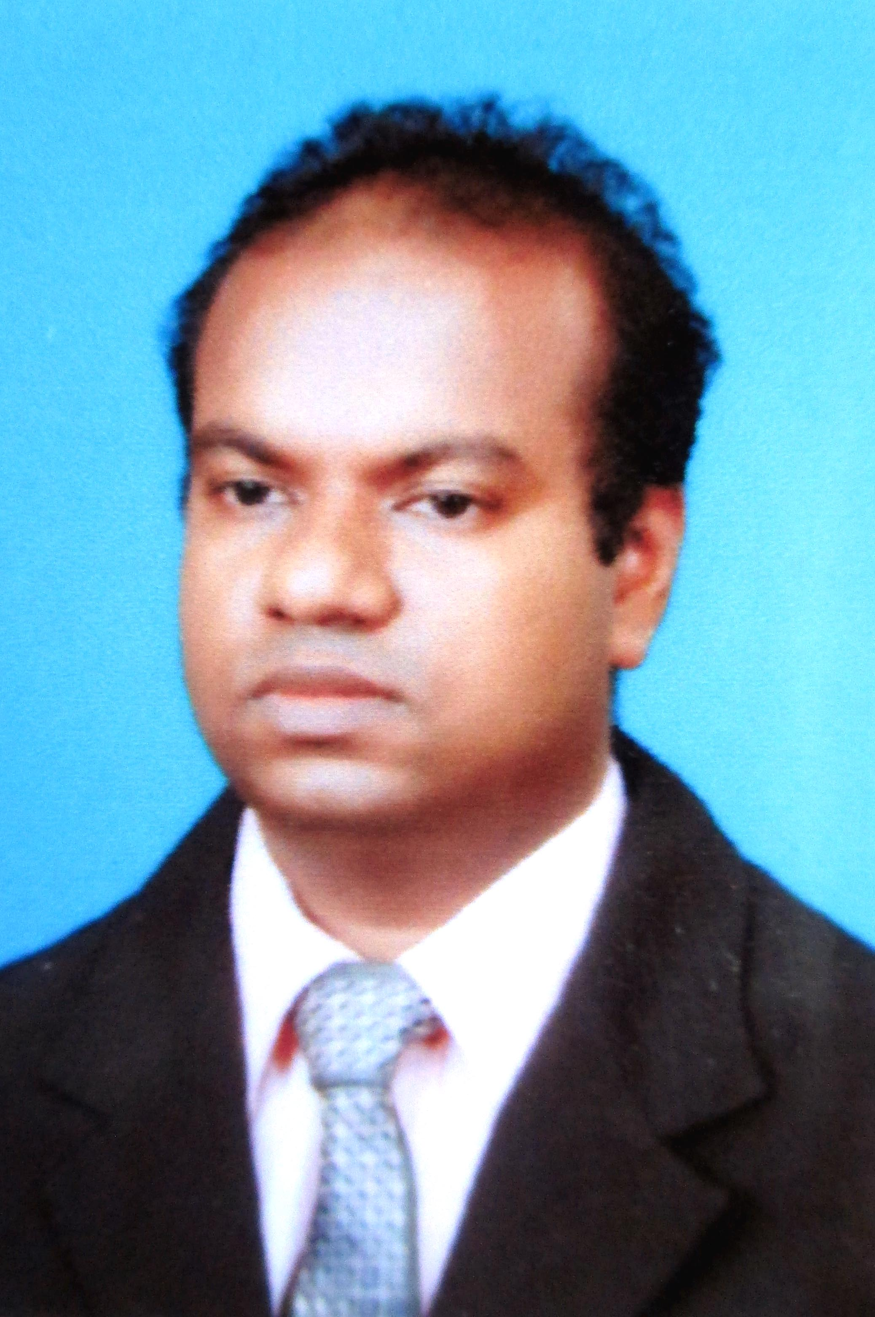

**T.M.A.R.Thennakoon**

**‘Sirimedura’**

**Mihinthala road,**

**Anuradhapura.**

**🖁0711937380**

**a.rajaguru.t@gmail.com**

**PERSONAL INFORMATION**

Name in Full : Thennakoon Mudiyanselage Arshana Rajaguru

Thennakoon

Name with Initials : T.M.A.R.Thennakoon

Address : ‘Sirimedura’ Mihinthala road, Anuradhapura.

Date of Birth : 28th of January 1990

Gender : Male

N.I.C. Number : 900282281 V

D.L Number : B2602477

Civil Status : Single

Nationality : Sinhala

School Attended : A/Niwaththakachethiya Maha Vidyalaya

District : Anuradhapura

**HIGHER EDUCATIONAL QUALIFICATION**

**University**

I completed Bachelor of Science in Agriculture **(Special)** degree in the Faculty of Agriculture, Rajarata University of Sri Lanka.

**Specialization Area**

* Agricultural Engineering

**MAJOR SUBJECTS OFFERED IN THE SPECIALIZATION AREA**

* Food Packaging
* Thermodynamics
* Farm Structure Development
* Irrigation and Water Management
* Groundwater Hydrology
* Scientific Writing
* Computer Programming
* Food Process Engineering
* Advanced Agricultural Machinery and Management.
* Application of Remote Sensing and GIS in Agriculture
* Water Resources of Sri Lanka
* Reservoir designing and Management
* Statistical Software Of Data Analysis
* Design Philosophy
* Introduction to Integrated Water resource Management

**OTHER MAJOR SUBJECT AREAS**

* Economic Theory
* Principles of Agricultural Extension
* Development Extension
* Principles of Marketing
* Agricultural Experimentation
* Agricultural Development Policy
* Farm Management
* Plant Production
* Plant Protection
* Introductory Soil Science
* Soil Fertility and Management
* English Language
* Computer Literacy

**Final year Research project**

Design, Development and Testing of Lowland Paddy Weeder at Faculty of Agriculture, Rajarata University of Sri Lanka.

**SECONDARY EDUCATIONAL QUALIFICATIONS**

* **Passed G.C.E. Advanced Level Examination in 2009**

**Subjects** **Grade**

Biology C

Chemistry C

Physics C

Common General Test 77

* **Passed G.C.E Ordinary Level Examination in 2004**

**Core Subjects** **Grade**

Science & Technology A

English A

Mathematics A

Sinhala Language A

Social Studies & History A

History B

Sinhala Literature C

Religion B

Business studies and Accounting C

Art C

**PROFESSIONAL QUALIFICATIONS**

* Completed vocational Training program in Institute of Post harvest Technology (IPHT).
* Completed Vocational Training Program on Operation and Maintenance of Micro Irrigation Systems in Farm Machinery Training Centre (FMTC).
* Completed Vocational Training Program on Operation and Maintenance of Tractors in Farm Machinery Training Centre (FMTC).
* Completed Vocational Training Program on Operation and Maintenance of Pumps and Other Equipments in Farm Machinery Training Centre (FMTC).
* Currently following a External Pharmacist course.

**COMPUTER LITERACY**

* Completed TEC kids cource in Tech Sri Lanka Anuradhapura.
* Completed DITEC Diploma in Esoft Anuradhapura branch
* Completed Hardware Engineering course in Rajarata Information Technology Centre (RITC)
* Basic level has achieved of the UCTIT (University student’s Competency Test of Information Technology) held by Ministry of higher education.
* Completed Tamil Language course in Rajarata University of Sri Lanka

**OTHER QUALIFICATIONS**

* Worked as head editor of the www.aswenna.com website for 2013 -2014
* Completed In-plant Training at Groundwater Section, National Water Supply and Drainage board, Anuradhapura

**PERSONAL INTERESTS**

* Engineering
* Marketing
* Food Processing
* Information technology
* Crop Production

**SKILLS & COMPETETENCIES**

* Good communication skills in Sinhala and English languages.
* Good presentation skills developed in academic presentation and assignments.
* Good innovative skills

**NON RELATED REFEREES**

**Mr. G.V.T.V.Weerasooriya**

Senior Lecturer,

Department of Agricultural Engineering and Soil Science,

Faculty of Agriculture,

Rajarata University of Sri Lanka,

Puliyankulama,

Anuradhapura.

Tel : +94714458680

[**Mr.P.D. Kahandage**](http://www.rjt.ac.lk/agri/soil/CV/pubudu.pdf)

Lecturer,

Department of Agricultural Engineering and Soil Science,

Faculty of Agriculture,

Rajarata University of Sri Lanka,

Puliyankulama,

Anuradhapura.

Tel : +94776606224

I do here by declare that the above furnished particulars are true and accurate to the best of my knowledge.

……………………………. ………………………

T.M.A.R.Thennakoon Date